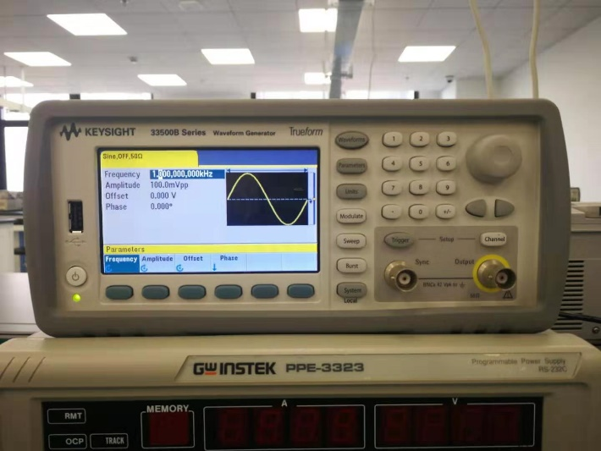

Briefly describe the key features of this wave generator. Describe the basic steps of how to use it. Remember to use appropriate signaling words when referring to the picture. And give the picture an appropriate numbering and caption.